LINEN SIZES

90X156 - Rectangle
90x132 - Rectangle
52X52 - Square
62X62 - Square
72X72 - Square
85X85 - Square
52X120 - Rectangle
120’ ROUND
90X90 – Square
All table linens come in white, black, and ivory

NAPKINS
Napkins come in a large variety of colors

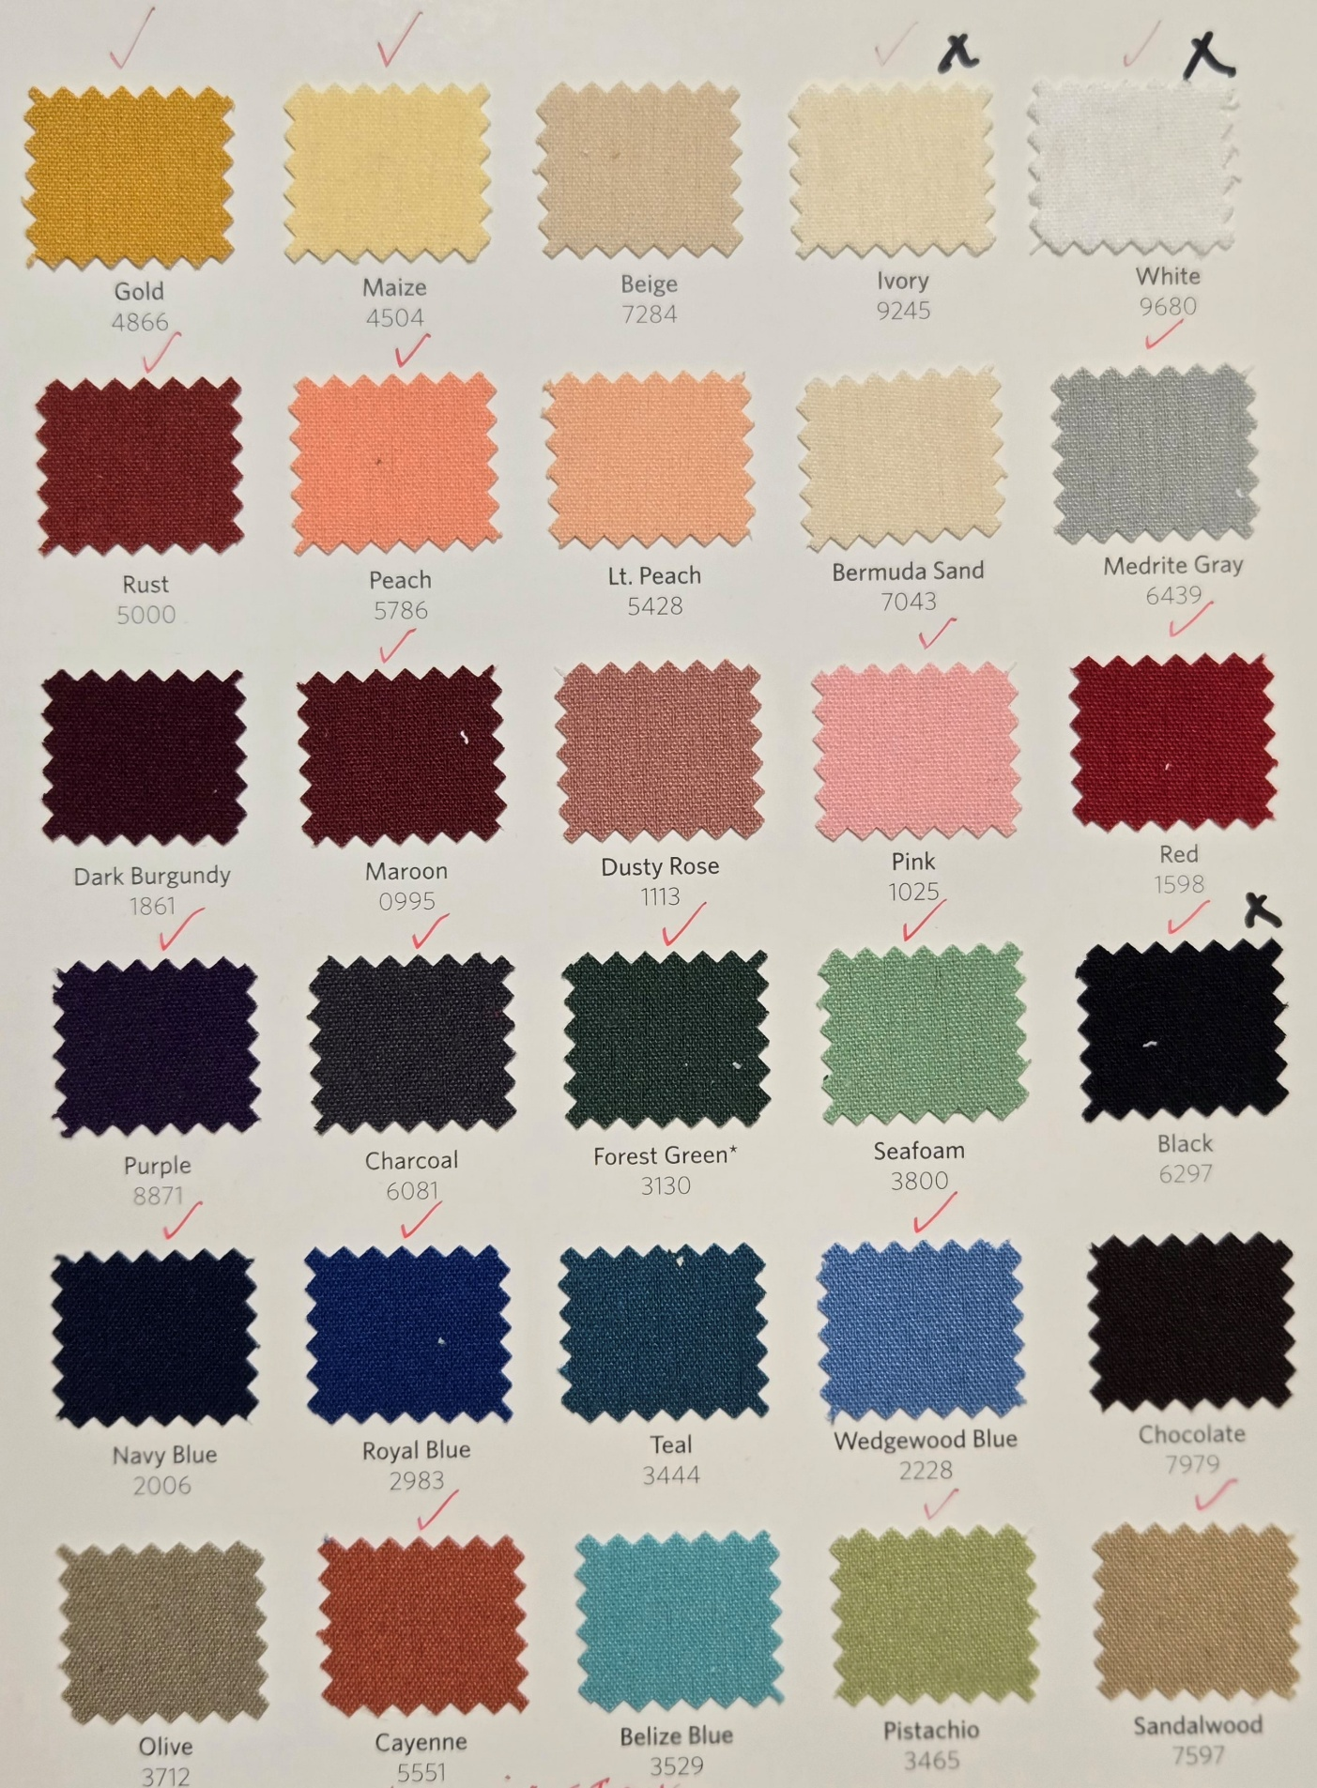
ALL RED “CHECK” MARKS ARE AVAILABLE COLORS IN NAPKINS, BLACK “X” FOR TABLECLOTHS
